Titan Advanced Energy Solutions Raises $33 Million Series B Led by HG Ventures to Transform Battery Diagnostics and Management

Titan’s ultrasound-based technology unlocks actionable intelligence inside batteries to realize better performance, longevity and safety

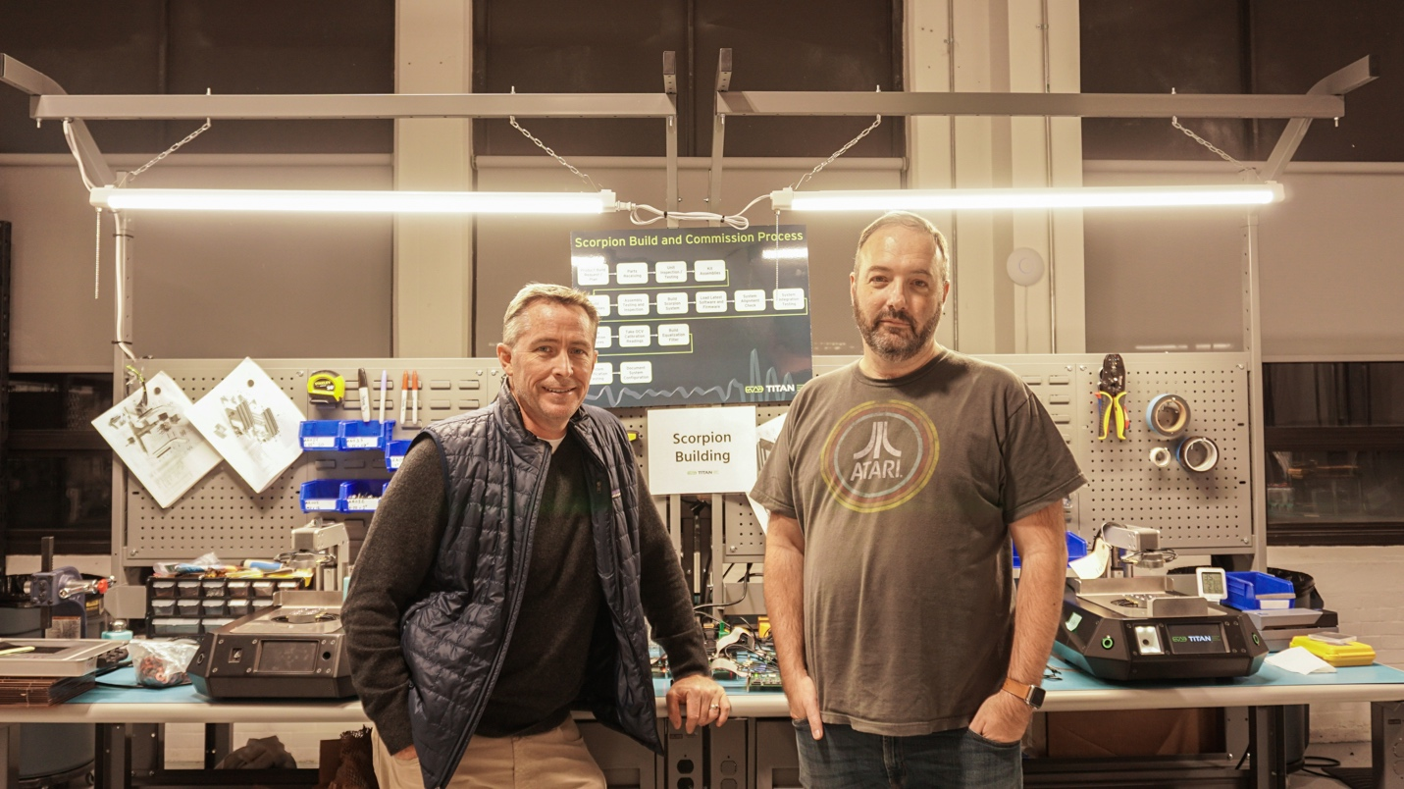

Salem, Mass. — November 16, 2021—Titan Advanced Energy Solutions (“Titan”), a pioneer in ultrasound-based battery management solutions, announced a $33 million Series B financing led by HG Ventures, the corporate investment arm of The Heritage Group. This new capital positions the company to accelerate industrial-scale deployments of its battery diagnostics and battery sensing/management technologies to drive safer and more efficient manufacturing, operation and repurposing of lithium-ion batteries.

Additional investors from the U.S., Europe, Asia and the Middle East included H+ Partners, GS Futures, the investment arm of the GS Group, GS Energy, Doral Energy-Tech Ventures, the investment arm of Doral Group and Fortistar, along with existing investors Energy Innovation Capital and SE Ventures, the investment arm of Schneider Electric.

“Our ultrasound-based technology spans the battery life cycle. From manufacturing and first use to second life and recycling,” said Shawn Murphy, CEO and co-founder of Titan. “We will continue to propel the shift toward electrification by solving critical issues impacting the performance and safety of new and reused lithium-ion batteries.”

Titan’s primary focus is on the automotive and stationary storage markets. The global EV batteries market is expected to grow from $19.78 billion in 2020 to $38.32 billion in 2025, and the global battery energy storage system market is projected to grow from $2.9 billion in 2020 to $12.1 billion by 2025.^{1,2}

“Titan’s focus on building a sustainable model of closed loop recycling for lithium-ion batteries aligns perfectly with HG Ventures’ mission of supporting cutting-edge disruptors in sustainability,” said Ginger Rothrock, Senior Director of HG Ventures. “We and our strategic syndicate partners are delighted to support Titan’s world-class team developing a platform that enables transformational improvements to the performance, economics and safety of lithium-ion batteries.” John Glushik, Managing Director of HG Ventures, will be joining Titan’s Board.

The future is battery powered. Titan was founded by two technology pioneers who engineered a breakthrough technology by applying the proven science of ultrasound to lithium-ion batteries. Our mission is to provide intelligence on any battery’s state of health, state of charge and safety profile — at any stage of its life and in real time. And ultimately to ensure that the trillions of batteries dumped in landfills today will join the circular economy of tomorrow to be repurposed, reused or recycled.

Today Titan’s solutions are being co-developed along with global auto manufacturers, multinational energy storage integrators and consumer electronics manufacturers in the United States and Europe.

Titan Advanced Energy Solutions
Titan Advanced Energy Solutions was founded in 2016 by technology entrepreneurs Shawn Murphy and Sean O’Day. Today, the Titan team has engineered a breakthrough technology by applying the proven science of ultrasound to lithium-ion batteries. We delve deeply into the inner workings of batteries to provide intelligence on any battery’s state of health, state of charge and safety profile — at any stage of its life and in real time. Our ultrasound technology leads to longer-lasting and better-performing batteries, all at a fraction of the cost of legacy battery technologies and with a greener overall footprint.

HG Ventures
HG Ventures is the corporate venture arm of The Heritage Group, headquartered in Indianapolis, Ind. HG Ventures supports innovation and growth across The Heritage Group by investing and partnering with innovative, high-growth companies to support a sustainable future. We leverage the world-class expertise of The Heritage Group operating companies and research center to offer a unique value proposition to our portfolio company partners. www.hgventures.com

¹Battery energy storage systems:
https://www.marketsandmarkets.com/Market-Reports/battery-energy-storage-system-market-112809494.html

²Global EV battery market: https://www.businesswire.com/news/home/20210819005494/en/Electric-Vehicle-EV-Batteries-Global-Market-Report-2021-Market-is-Expected-to-Reach-38.32-Billion-in-2025---Forecast-to-2030---ResearchAndMarkets.com

###

Media Contact:
Flavia Calvar
Titan Advanced Energy Solutions
617-866-0203
flavia@titanaes.com

